Task 3 Hologrphic Layout
Using the demand from task 1 and 2, we got the per part demand to cater to XXX % service levels for both clients A and B together. Using that as the input and table of steps by equipment for each part, we got the equipment needed for processing each part considering a functional organization.
Operating Assumptions Used
Schedule: 5days/week, 2shifts/day(recommended), 8hours/shift
Efficiency: 90%
Reliability: 98%
Effective Availability: 88.2% (0.90 × 0.98)
Availability per equipment:
- 1 shift: 2,116.8 minutes/week
- 2 shifts: 4,233.6 minutes/week
Key Characteristics:
The holographic system breaks up the system into a number of identical self-contained units. These units are capable of running the entire functionality of the system in a manner that they run the same application at 1/n scale of the whole capacity. This is compared to having a single large monolithic
- Self-similar: The system is built of units that are complete mini-systems in themselves.
- Redundant: On the failure of a particular unit, the load is absorbed by others without disruption.
- Scalable: Addition or removal of units, based on load or demand.
- Flexible: A workload or task can be spread over multiple units for enhanced efficiency.

The utilization is as below
Process | Equipment/Center | Utilization
A | 4 | 92.8%
B | 12 | 98.1%
C | 4 | 84.5%
D | 17 | 98.9%
E | 8 | 87.2%
F | 9 | 91.5%
G | 4 | 73.1%
H | 12 | 87.9%
I | 11 | 93.6%
J | 19 | 97.2%
K | 3 | 82.2%
L | 12 | 94.0%
M | 19 | 98.7%
TOTAL | 134 | 90.8%

Using 4 fractal configuration, we proceed to the facility layout next
Distance between each centre :

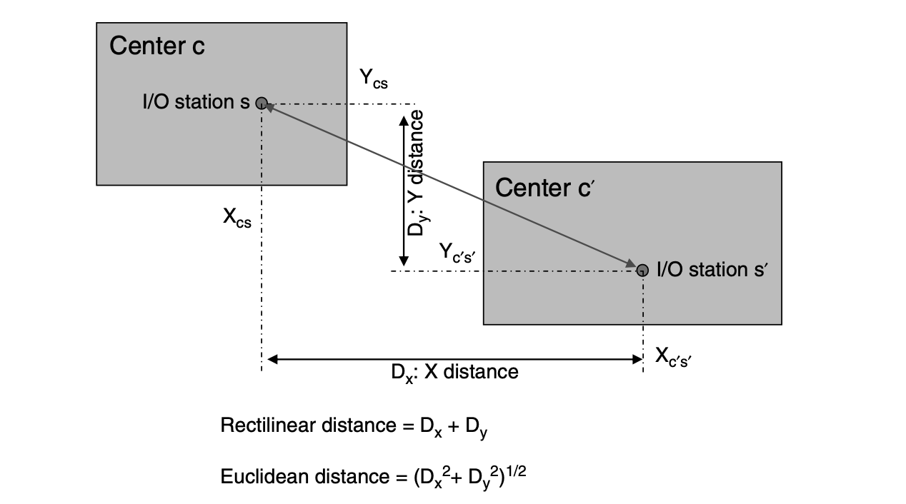

Output of various steps used to create a holographic layout:
· Step 1: Find the aggregate flow Matrix between various equipment and categorize the flows as highest to lowest.
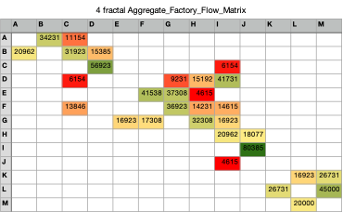
· Step 2: Make arrows that signify the flow's basis the thickness. Thicker the arrow, higher the flow
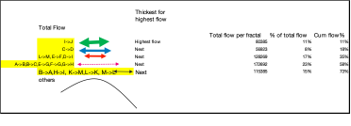
· Step 3: Sort the equipment’s (processers, for the individual equipment) needed basis numbers, list the size of each equipment and hence total area needed per centre of equipment cluster. (Assumption used here is size of equipment A = B=C=D =ABCD and similar for others)
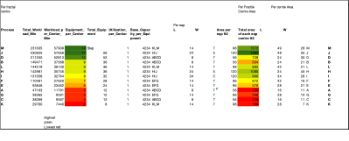
·

Step 4&5:Then edit the size of excel cells in the tab to represent a scale down block of 10ftx10ft (10:1 scale). Map each of the equipment centre (over all size of the centre basis number of equipments per fractal) basis step 3 output
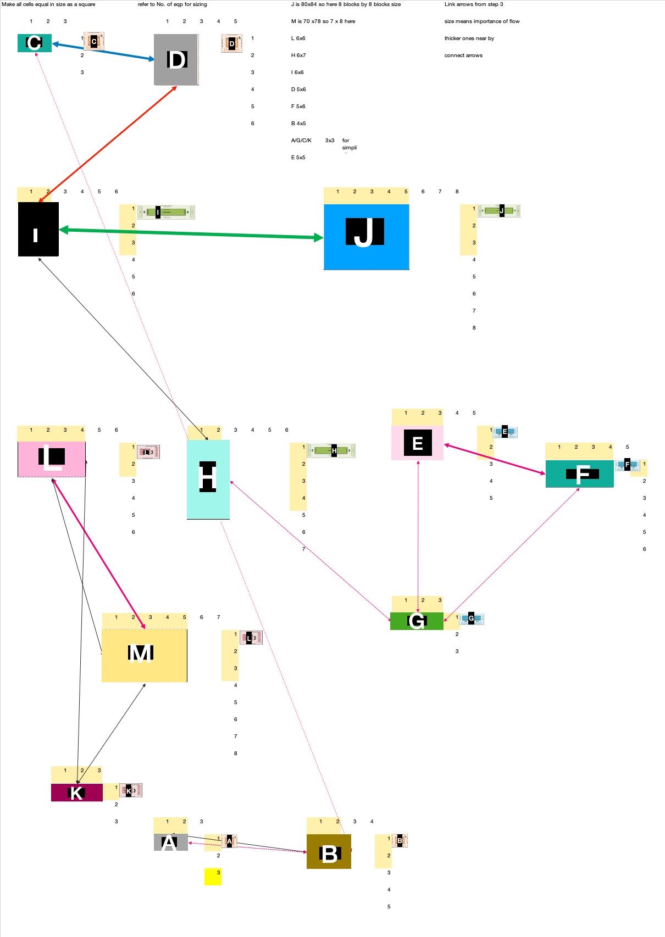
·

Step 6 and 7: In this I am taking the number of machine centres as 4 as it covers all flour corners of the factory layout and having 4 reduces the flow across the machine and improve the utilisation of area it is similar to functional layout but split in 4 parts to handle redundancy and to be accessible from all corners of the factory.

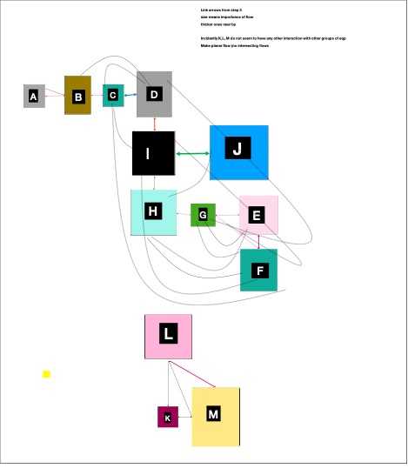
·

Step 8: Now put the equipment centres together to arrive at the facility layout. Another assumption considered here is that each processor (individual equipment within the centre) has enough space for Men and Material movement so we are not designing the aisles separately (as shown in the equipment spatial envelope below).

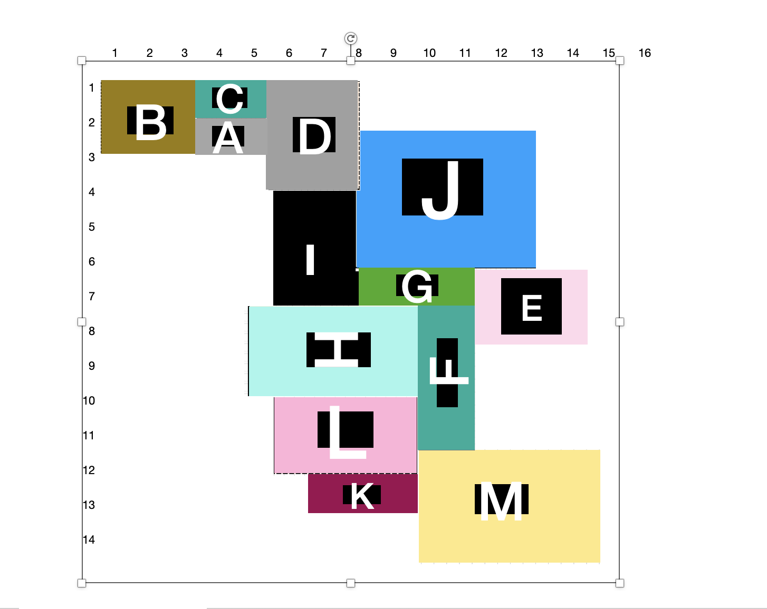

· Step 9: Since each cell in the layout in excel represents 10ft by 10 ft size, we can use the same for marking distances and arrive at x, y coordinates for each centre in the fractal. Assumption used here is we have gone with Euclidian distance here for speed and maintained the same across for consistency in evaluations. For calculating the distance we have used each corner as an anchor and found the overall flow and movement in the layouts.

· Step 10: We then determine the distance between each centre basis the flow matrix as well as distance matrix and arrive at the KPI of Distance per trip for the entire layout.

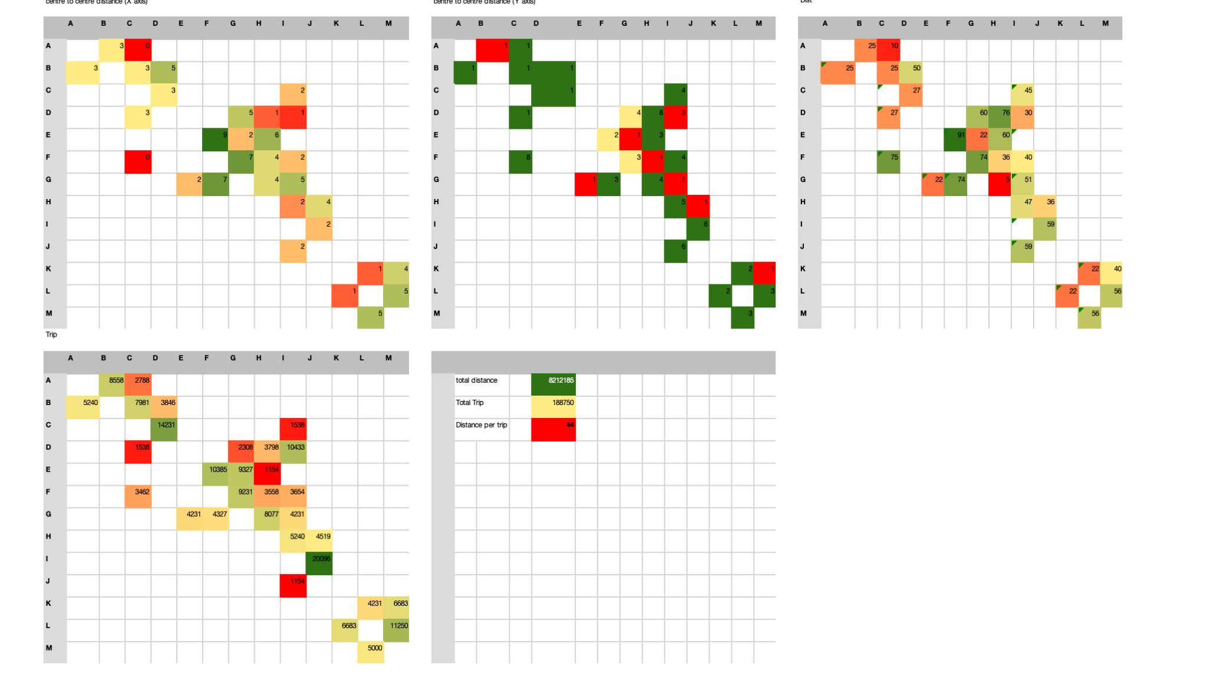
·

Step 11:
We then place all the equipment to get the final factory layout. We can add all the individual equipment to this to make a holographic layout.

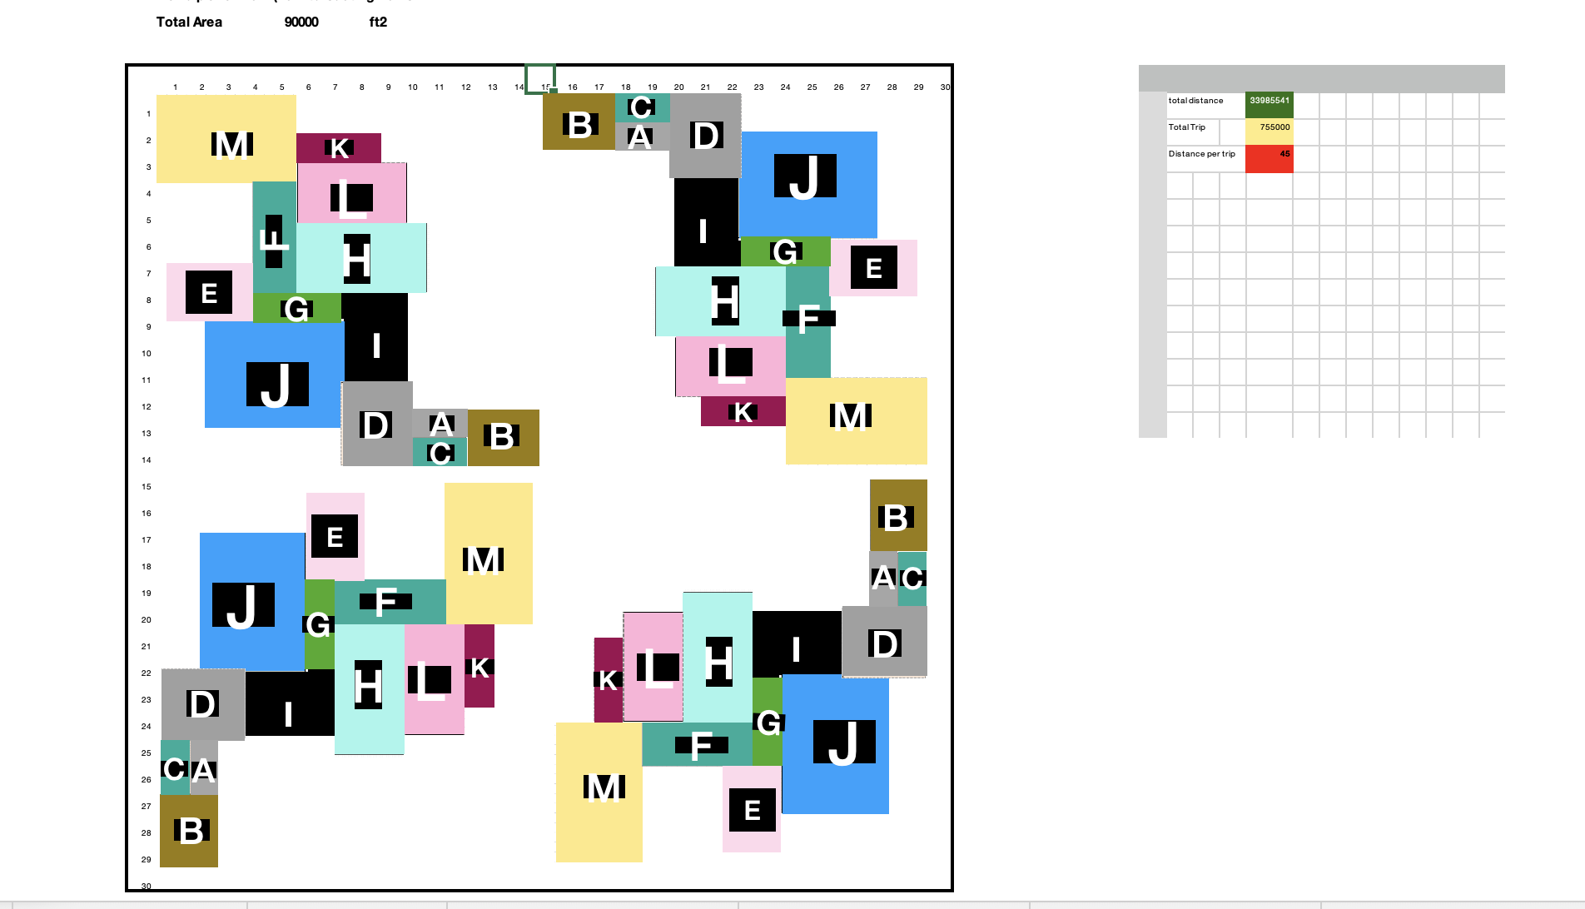

Overall cost calculation:
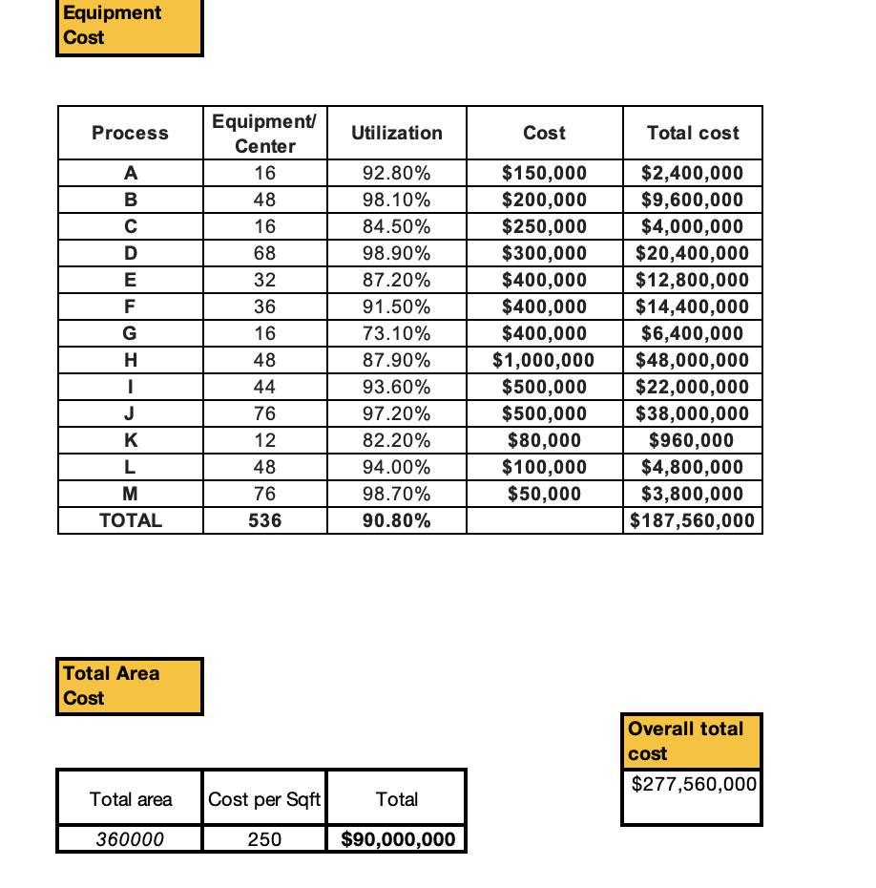

No of operators:
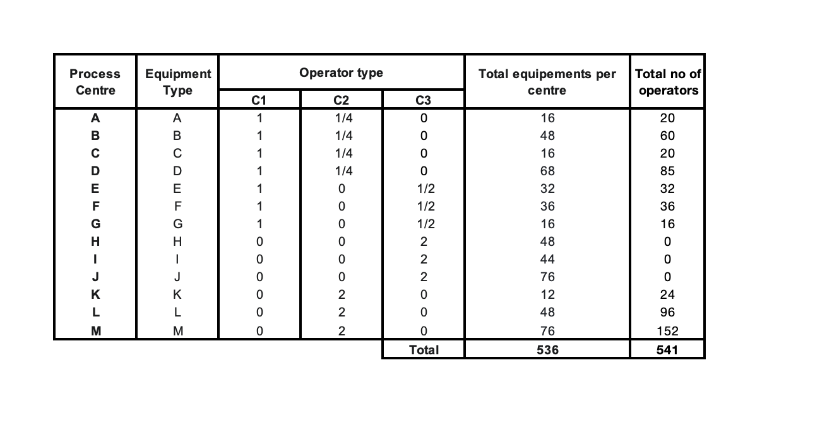
No of eqp | investment $ (combining eqp and area) | Area (sqft) | Distance per trip (ft/trip) | Number of operators (#) | Overall Utilization
400 | 227560000 | 360000 | 45 | 541 | 90.8

